Join and union sql azure
Join
Create a query with 2 tables employee and department and insert values to both tables
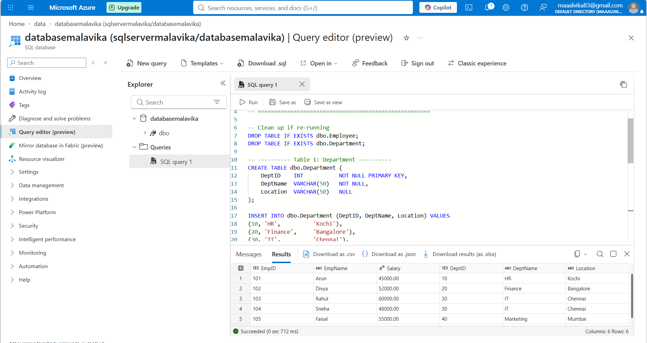
-- =====================================================
-- Azure SQL Database: tables for ADF Join & Union demo
-- Run in Azure Portal > SQL Database > Query editor
-- =====================================================

-- Clean up if re-running
DROP TABLE IF EXISTS dbo.Employee;
DROP TABLE IF EXISTS dbo.Department;

-- ---------- Table 1: Department ----------
CREATE TABLE dbo.Department (
DeptID INT NOT NULL PRIMARY KEY,
DeptName VARCHAR(50) NOT NULL,
Location VARCHAR(50) NULL
);

INSERT INTO dbo.Department (DeptID, DeptName, Location) VALUES
(10, 'HR', 'Kochi'),
(20, 'Finance', 'Bangalore'),
(30, 'IT', 'Chennai'),
(40, 'Marketing', 'Mumbai'),
(50, 'Operations', 'Hyderabad'); -- no employees here (shows inner join dropping it)

-- ---------- Table 2: Employee ----------
CREATE TABLE dbo.Employee (
EmpID INT NOT NULL PRIMARY KEY,
EmpName VARCHAR(50) NOT NULL,
Salary DECIMAL(10,2) NULL,
DeptID INT NULL -- links to Department.DeptID
);

INSERT INTO dbo.Employee (EmpID, EmpName, Salary, DeptID) VALUES
(101, 'Arun', 45000.00, 10),
(102, 'Divya', 52000.00, 20),
(103, 'Rahul', 60000.00, 30),
(104, 'Sneha', 48000.00, 30),
(105, 'Faisal', 55000.00, 40),
(106, 'Meera', 47000.00, 10),
(107, 'Kiran', 50000.00, NULL); -- no department (shows inner join dropping it)

-- ---------- Verify ----------
SELECT * FROM dbo.Department;
SELECT * FROM dbo.Employee;

-- Expected inner join result (what your data flow should output): 6 rows
SELECT e.EmpID, e.EmpName, e.Salary, d.DeptID, d.DeptName, d.Location
FROM dbo.Employee e
INNER JOIN dbo.Department d ON e.DeptID = d.DeptID;
Create a new dataflow
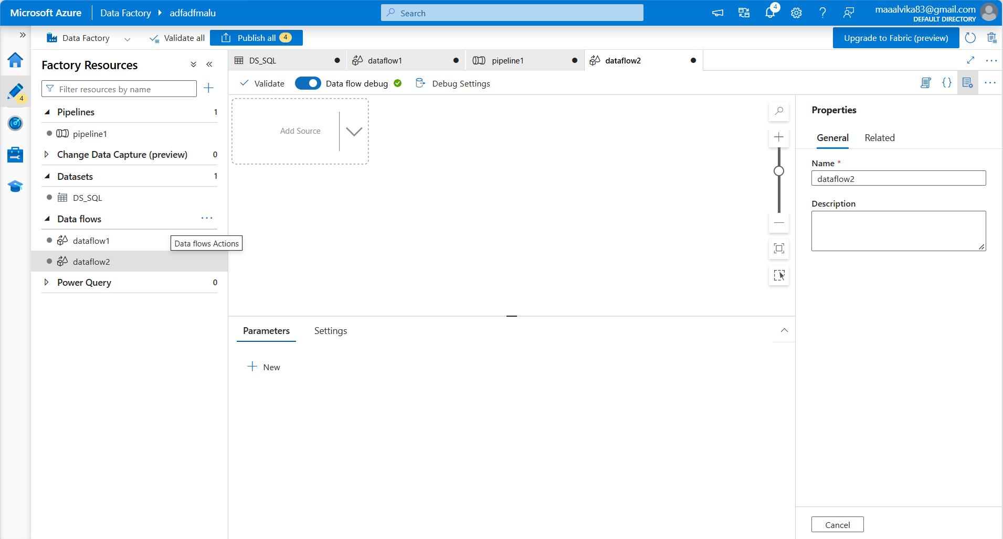
Create 2 datasets for source1 and source2 wherein source1 contains employee table and source2 contains department table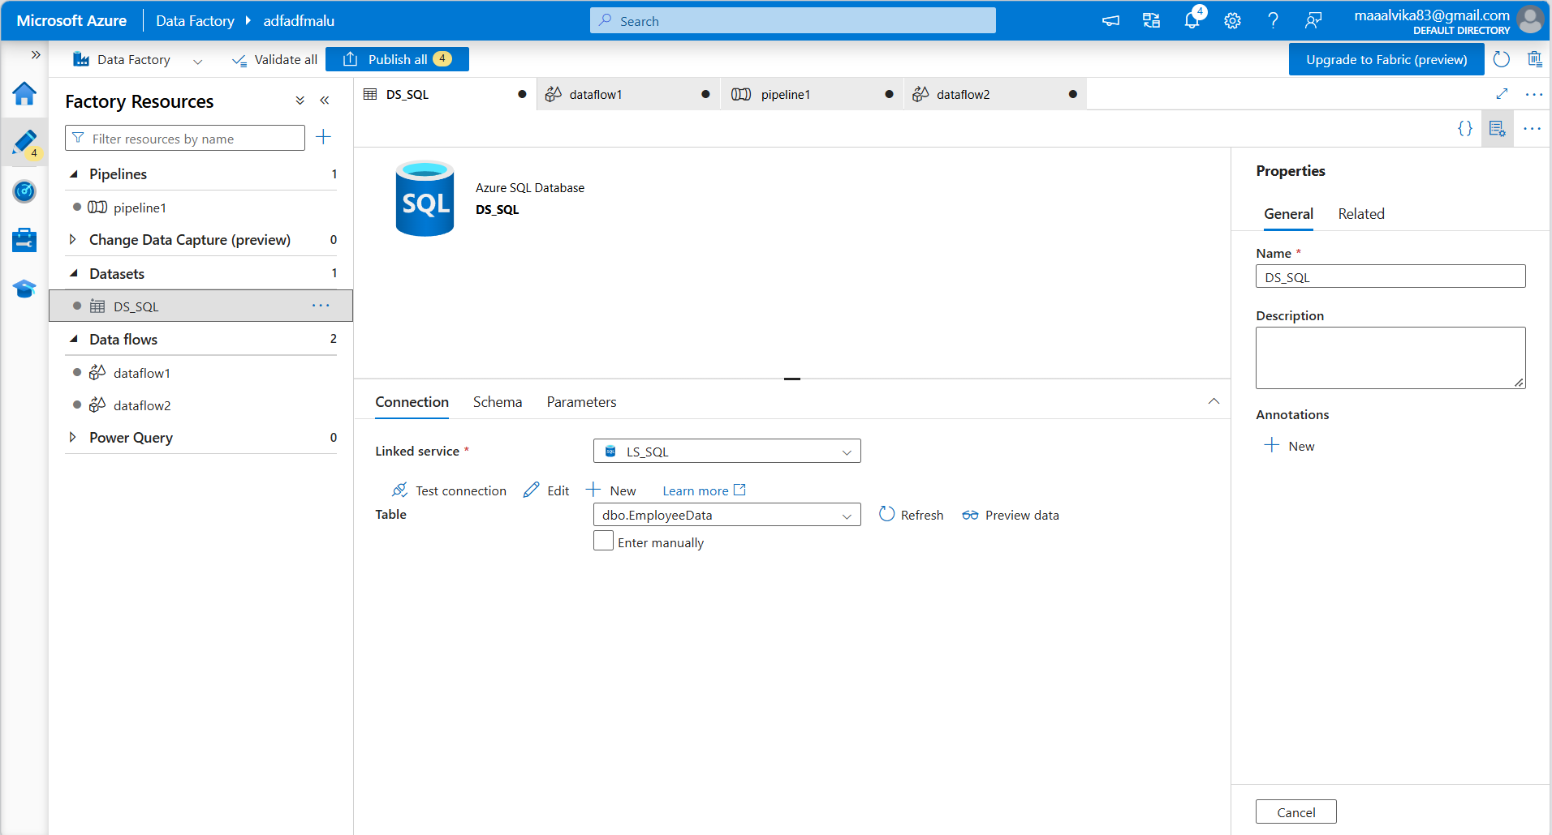

Azure sql database is selected as dataset for both sources
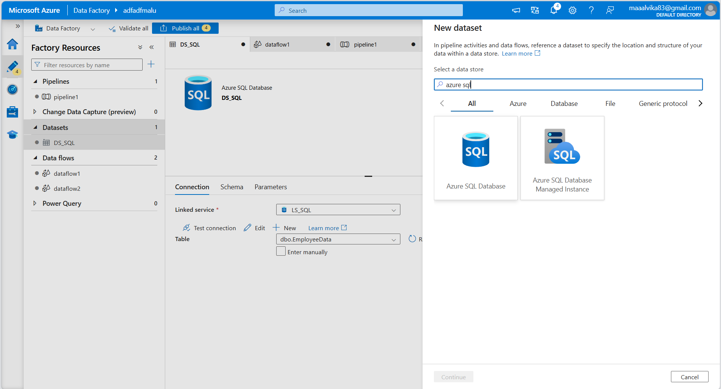
Create a linked service also
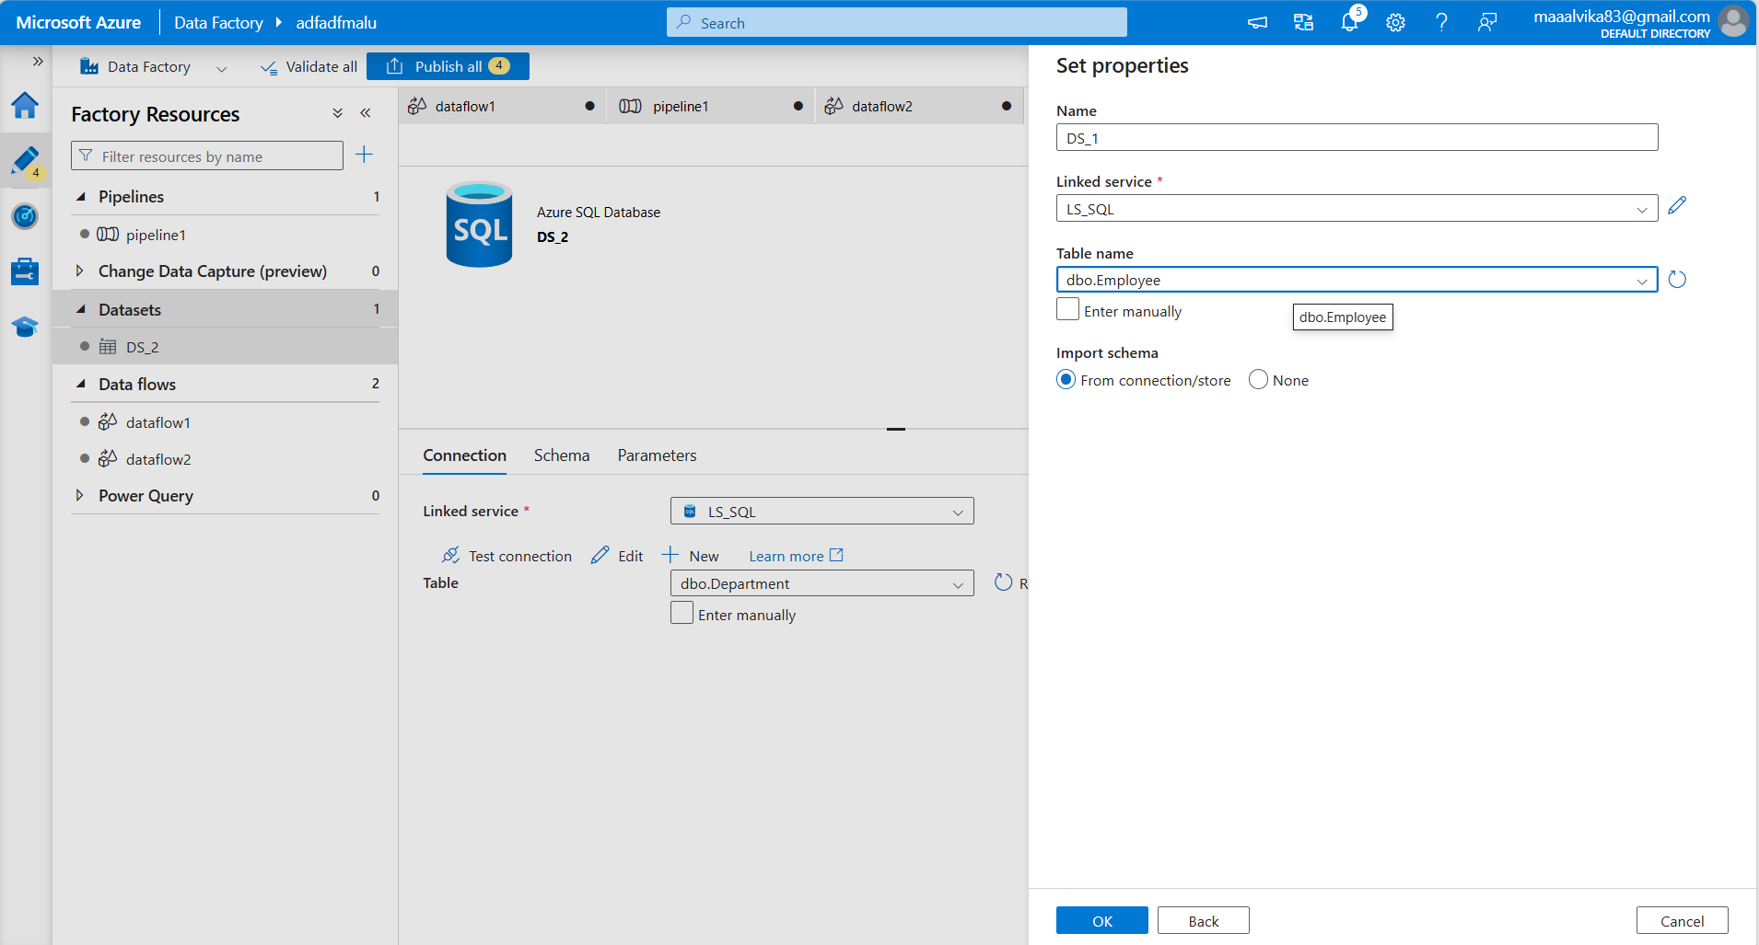

Join operation is selected to join both the sources
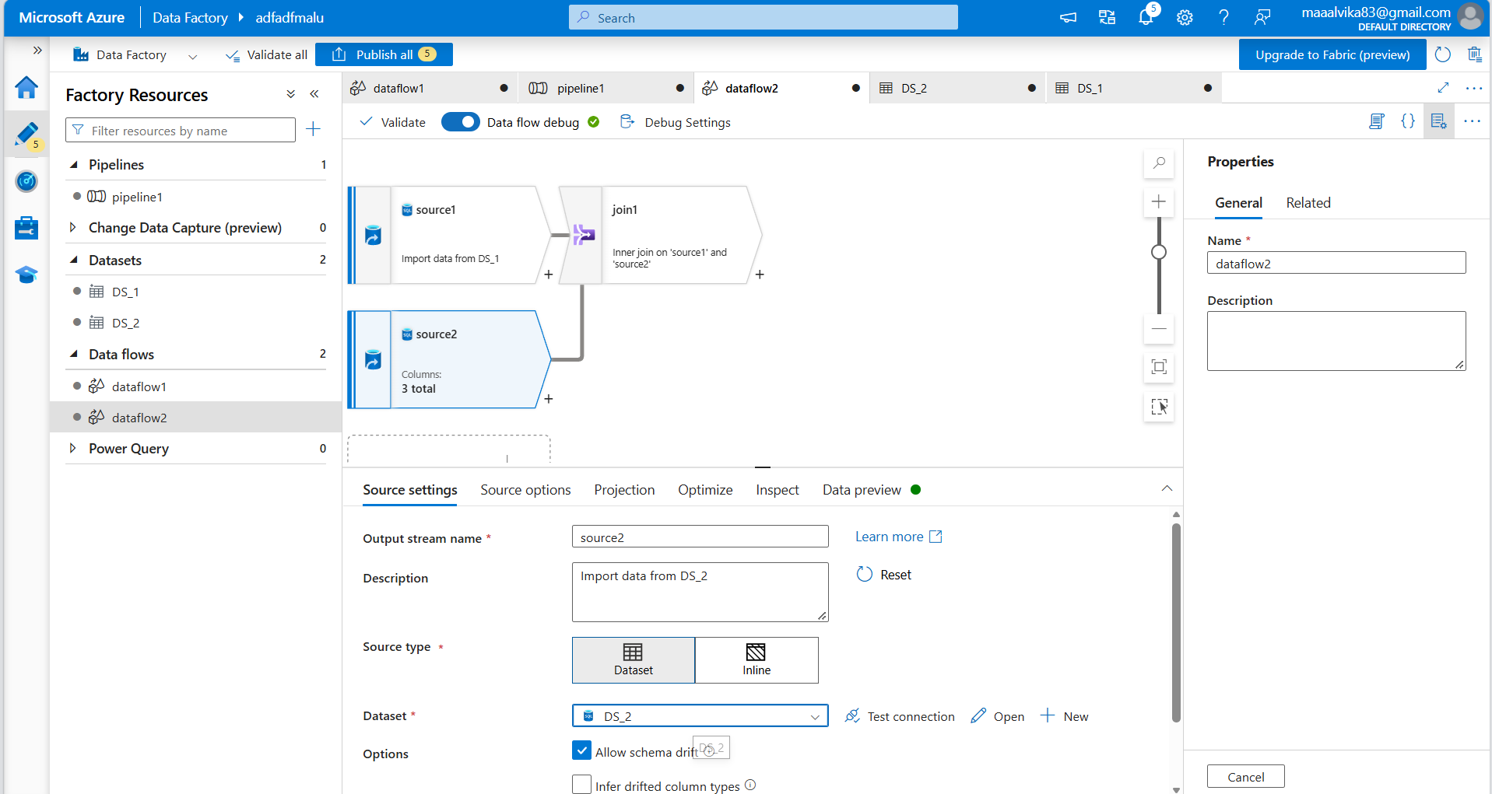
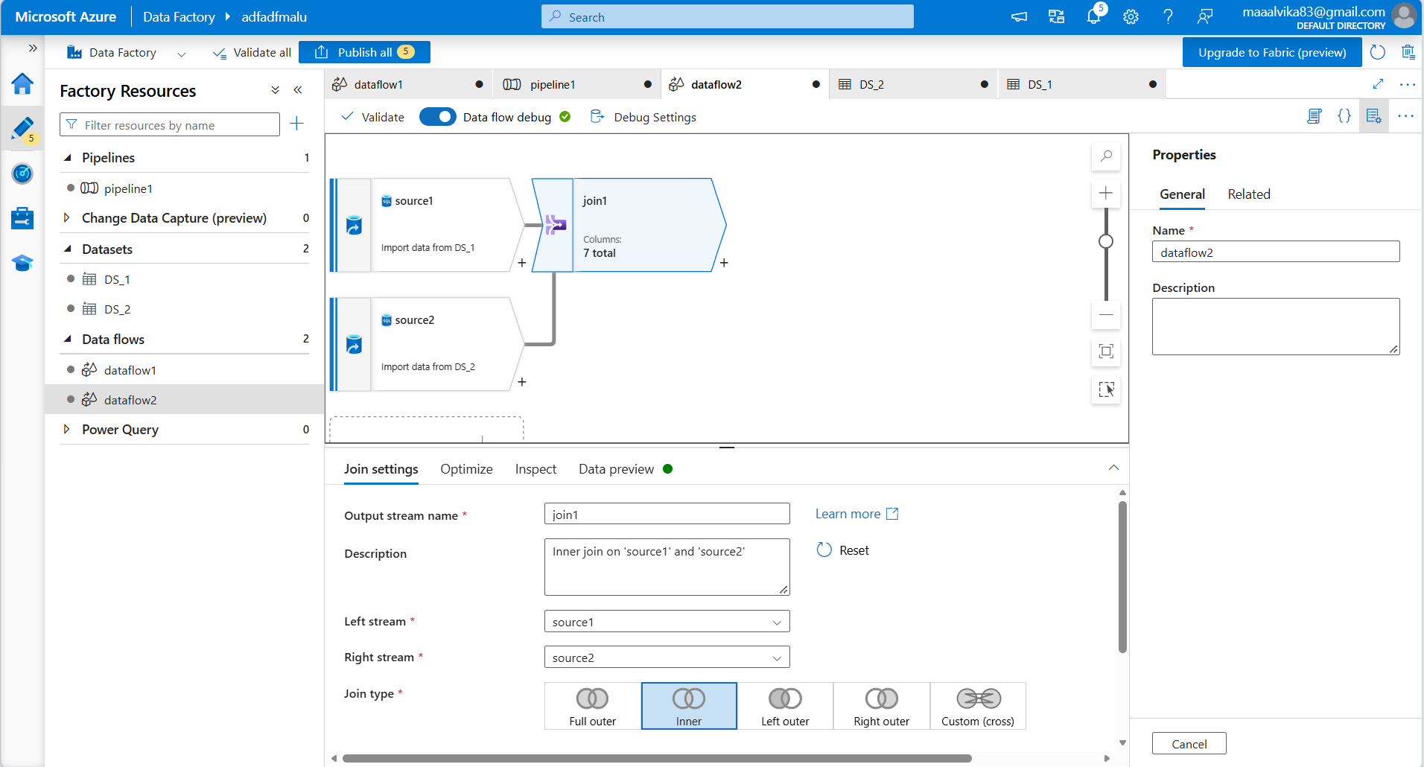

Specify the join condition
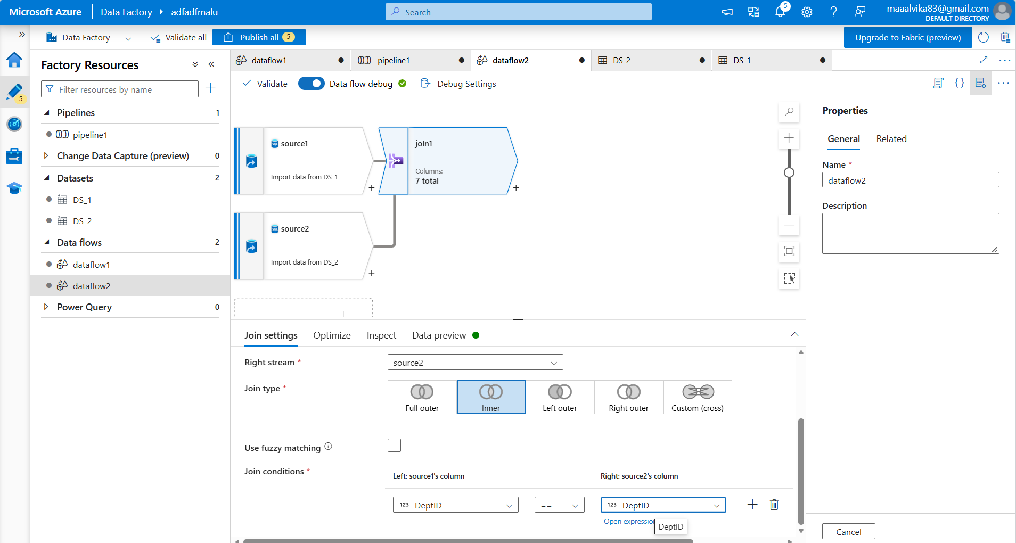
Add sink operation to the dataflow and select the dataset for sink
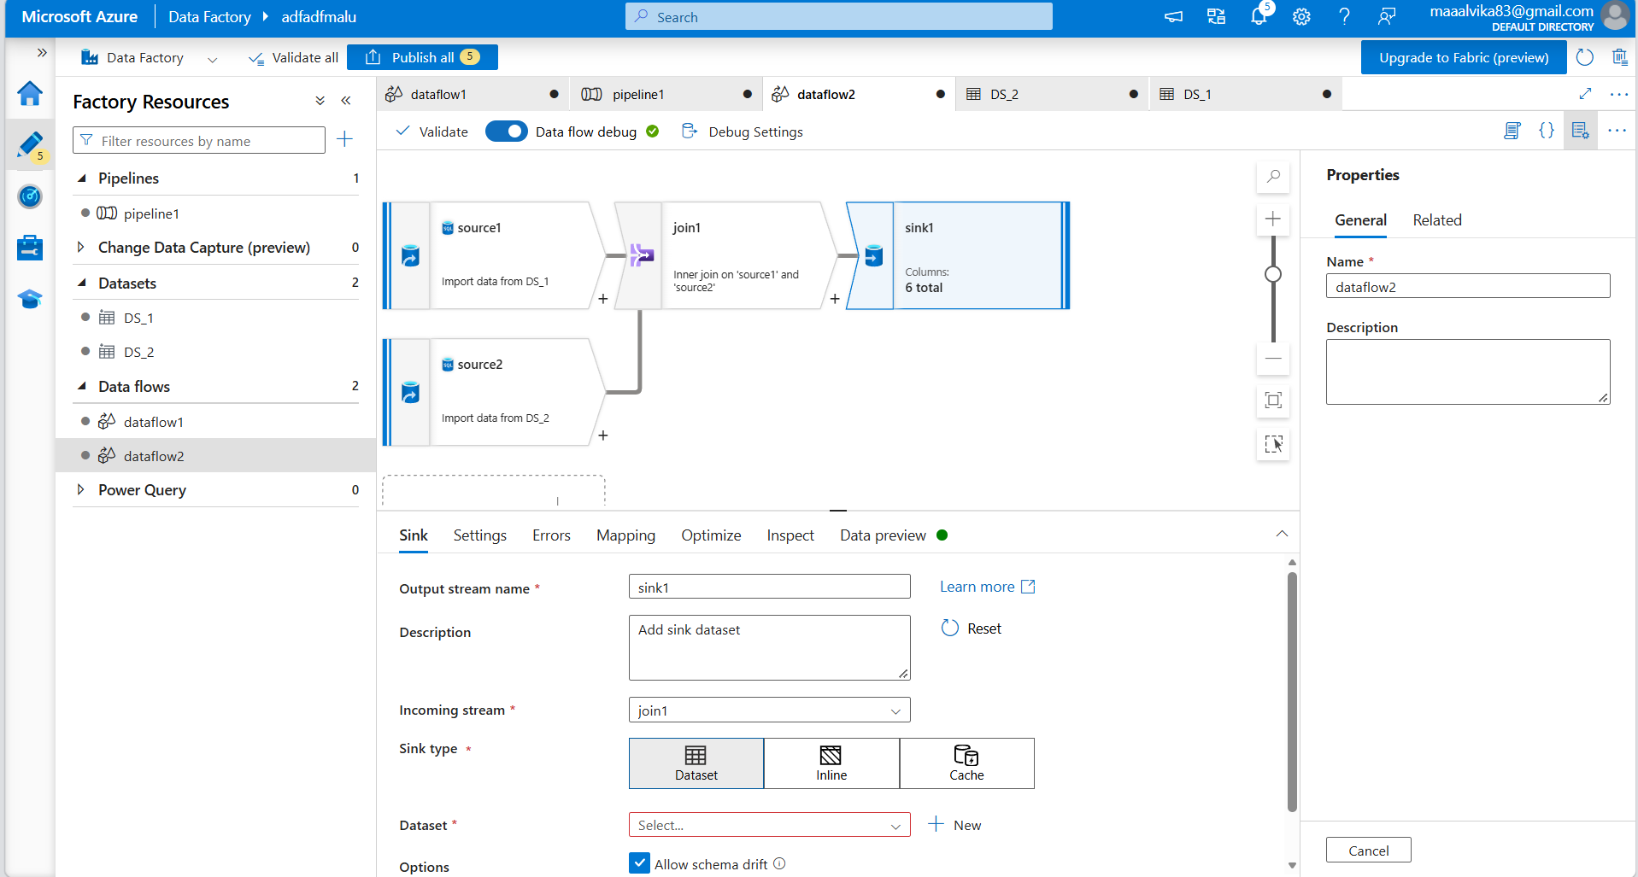

The dataset for sink uses azure blob storage and json format
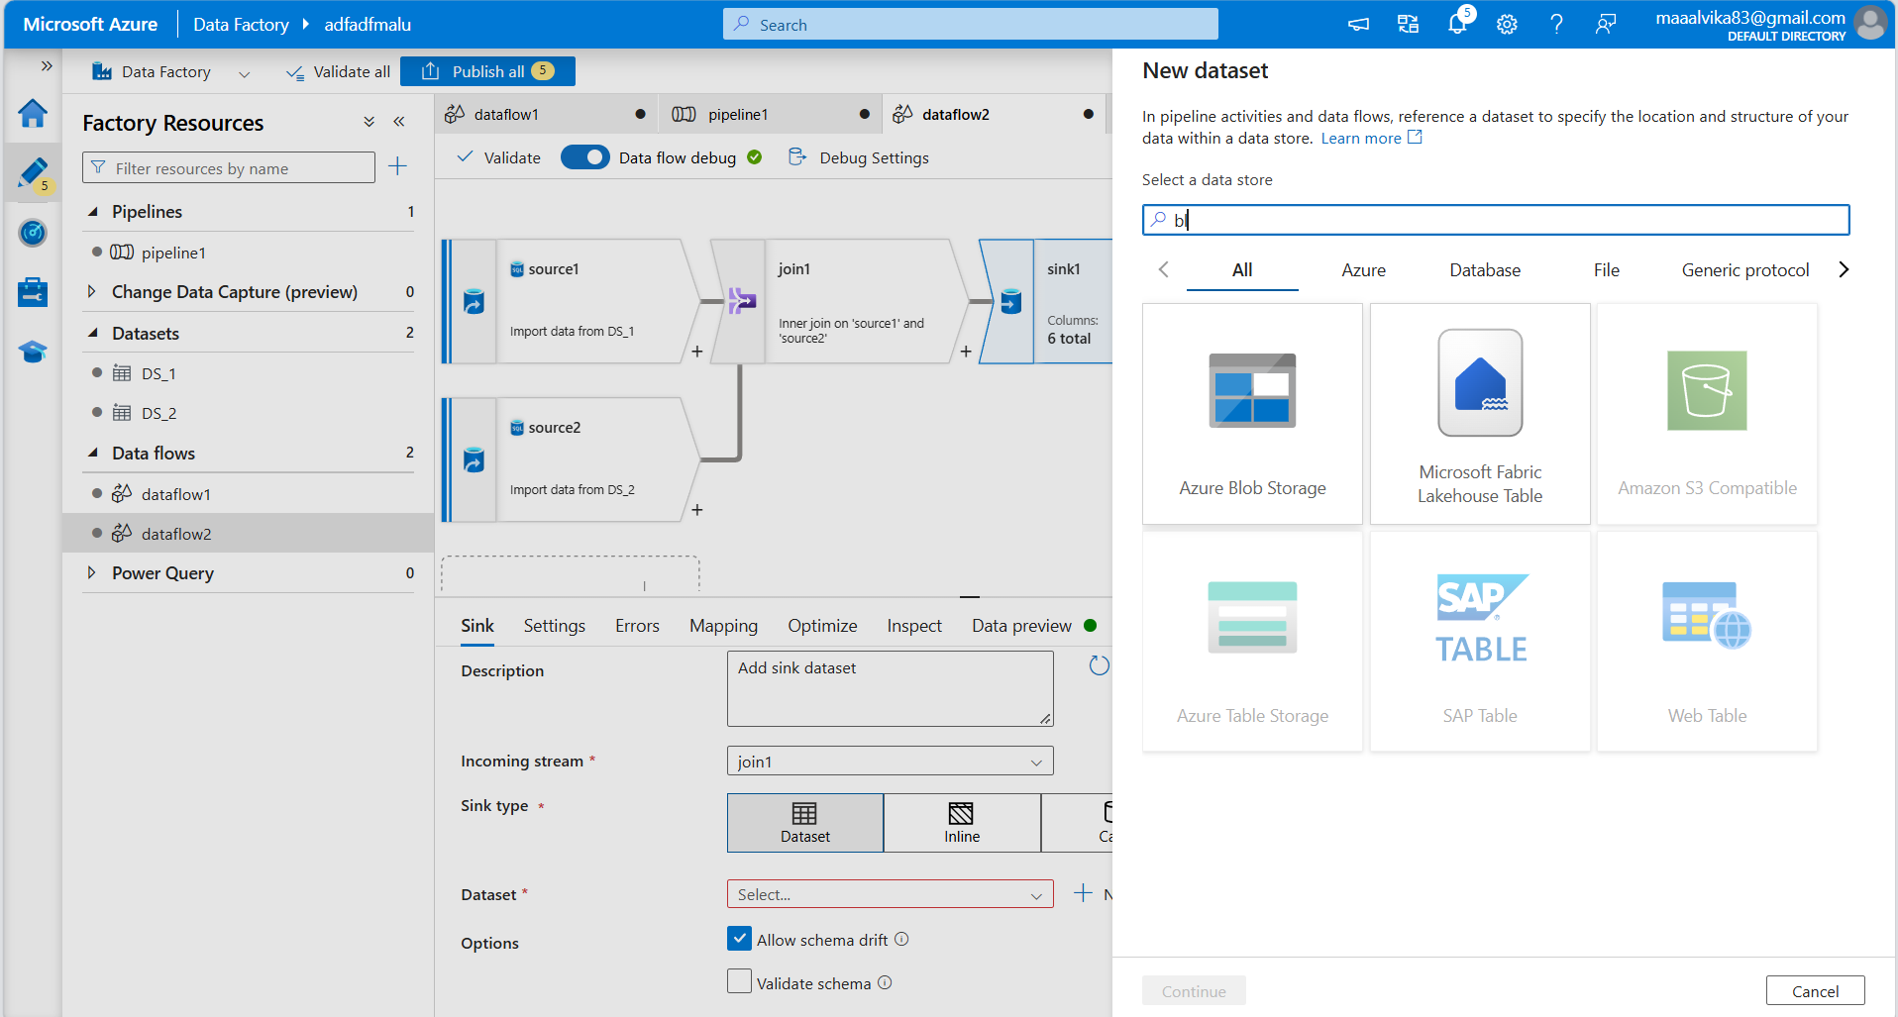
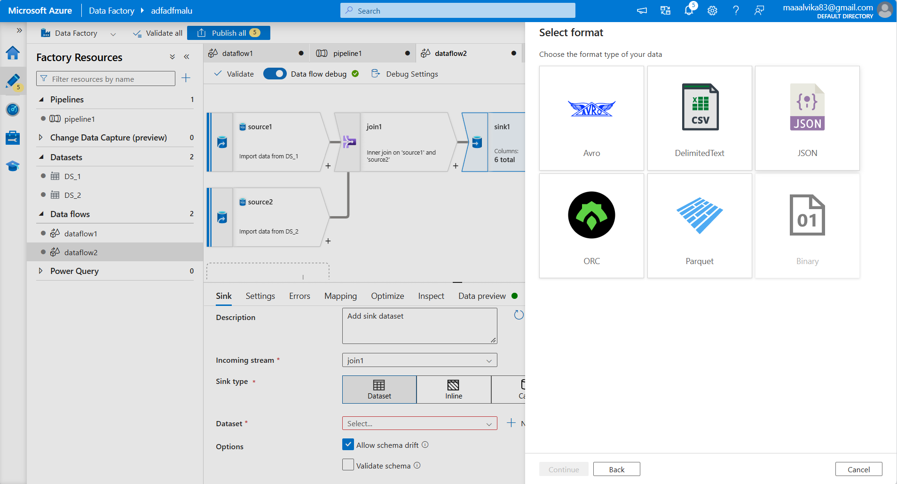

Create another linked service for blob storage
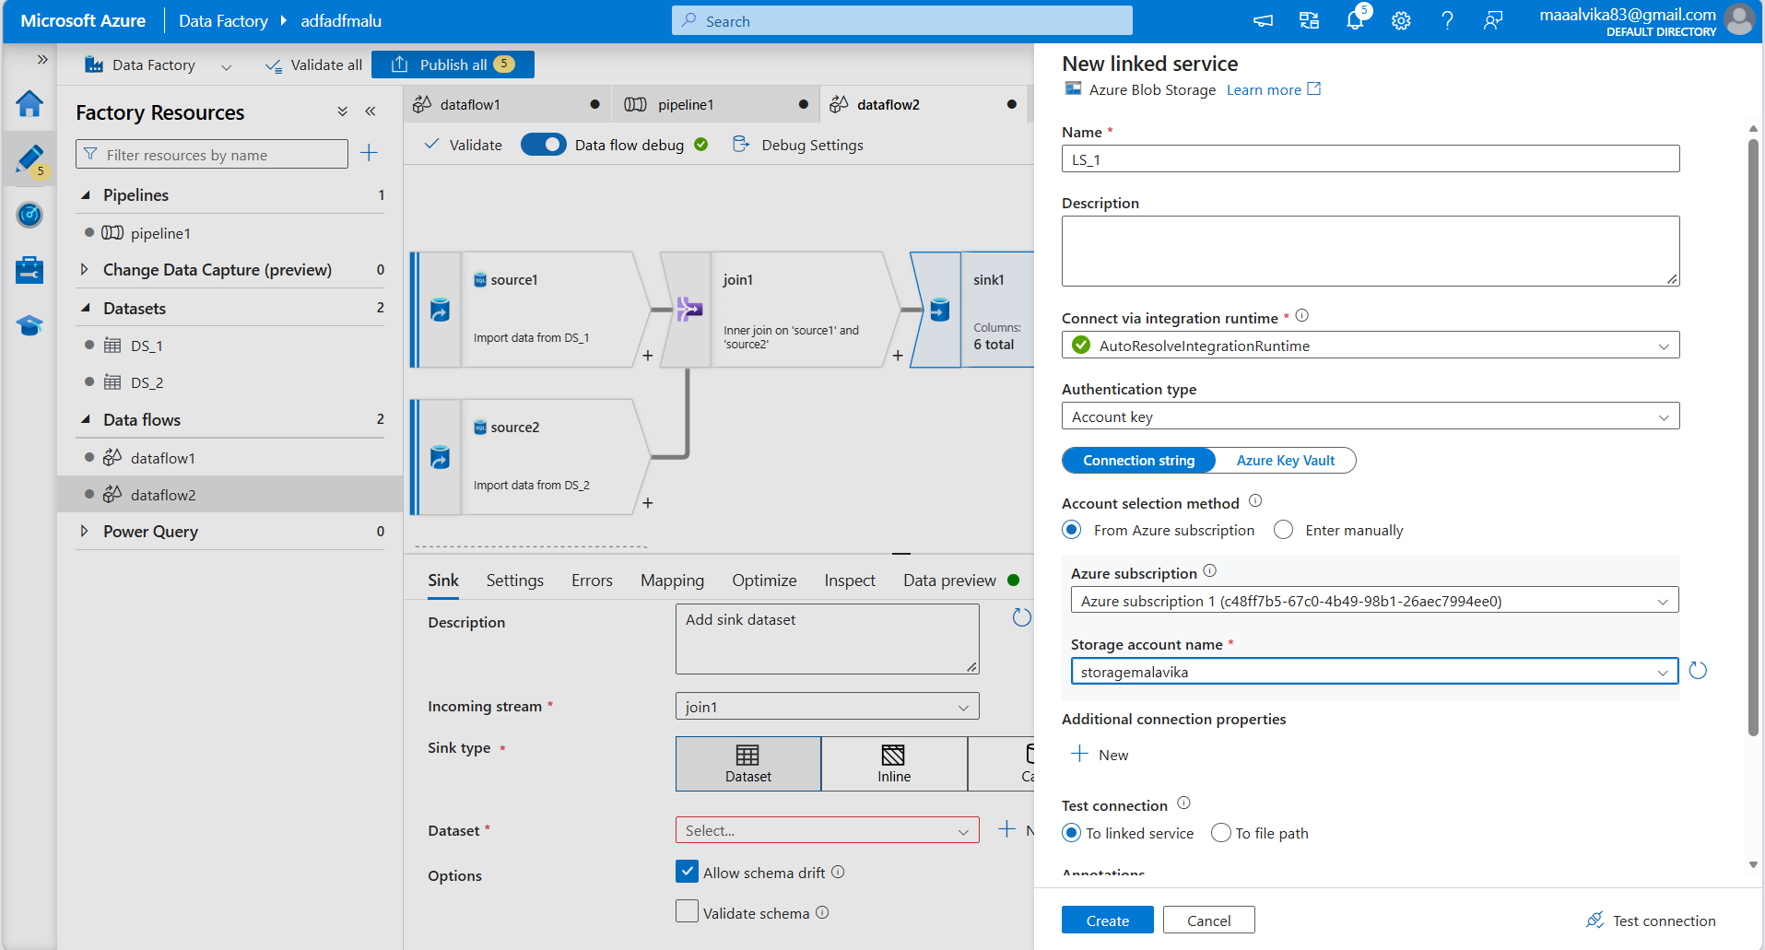
Create a container in storage account
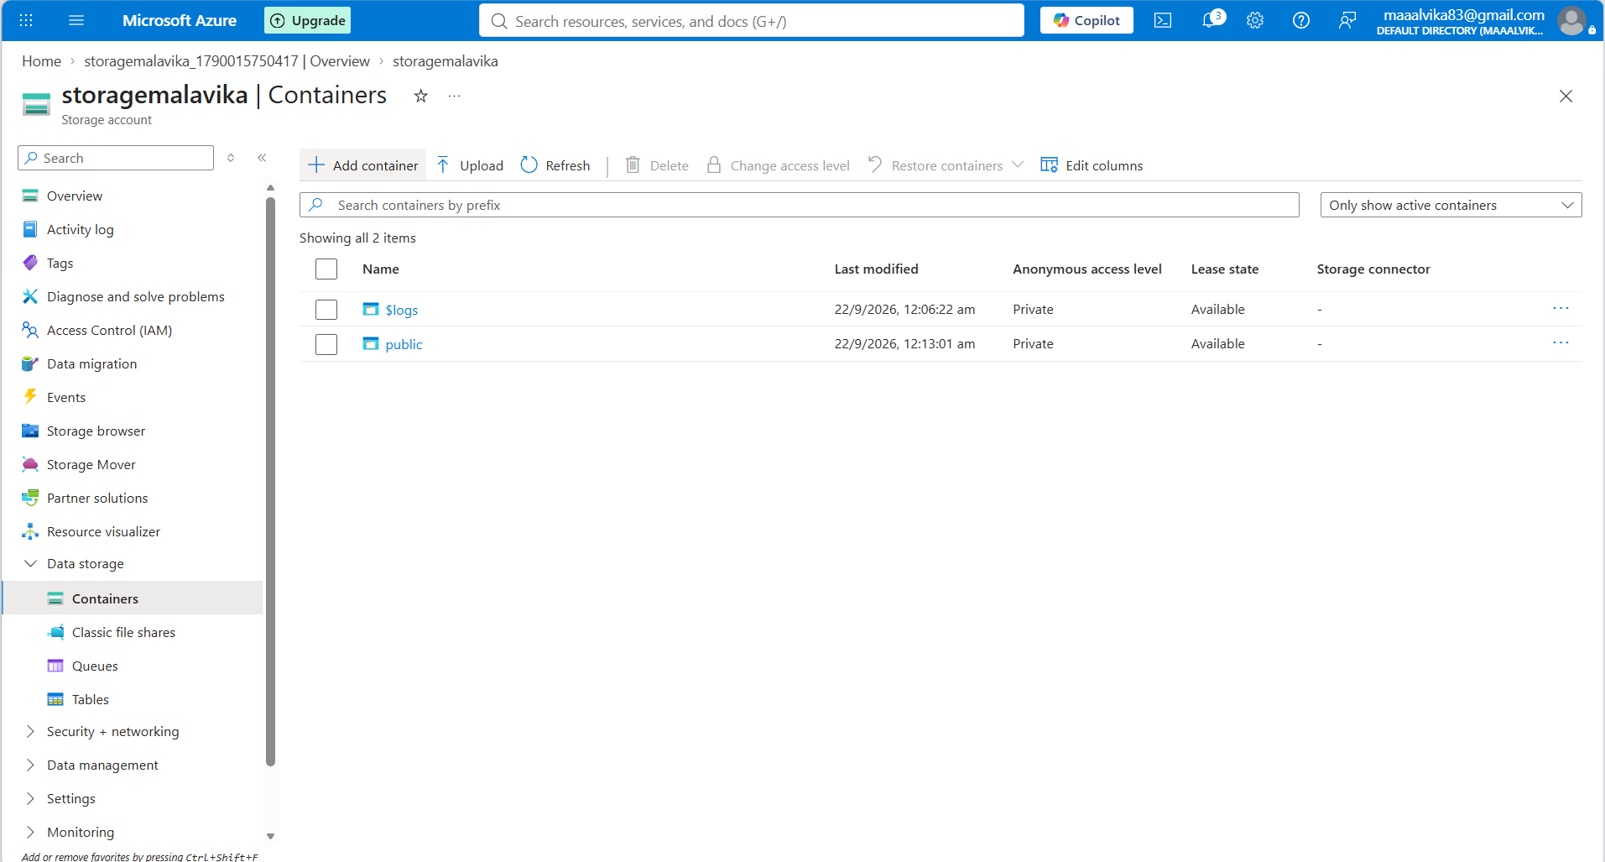

File path must be name of container
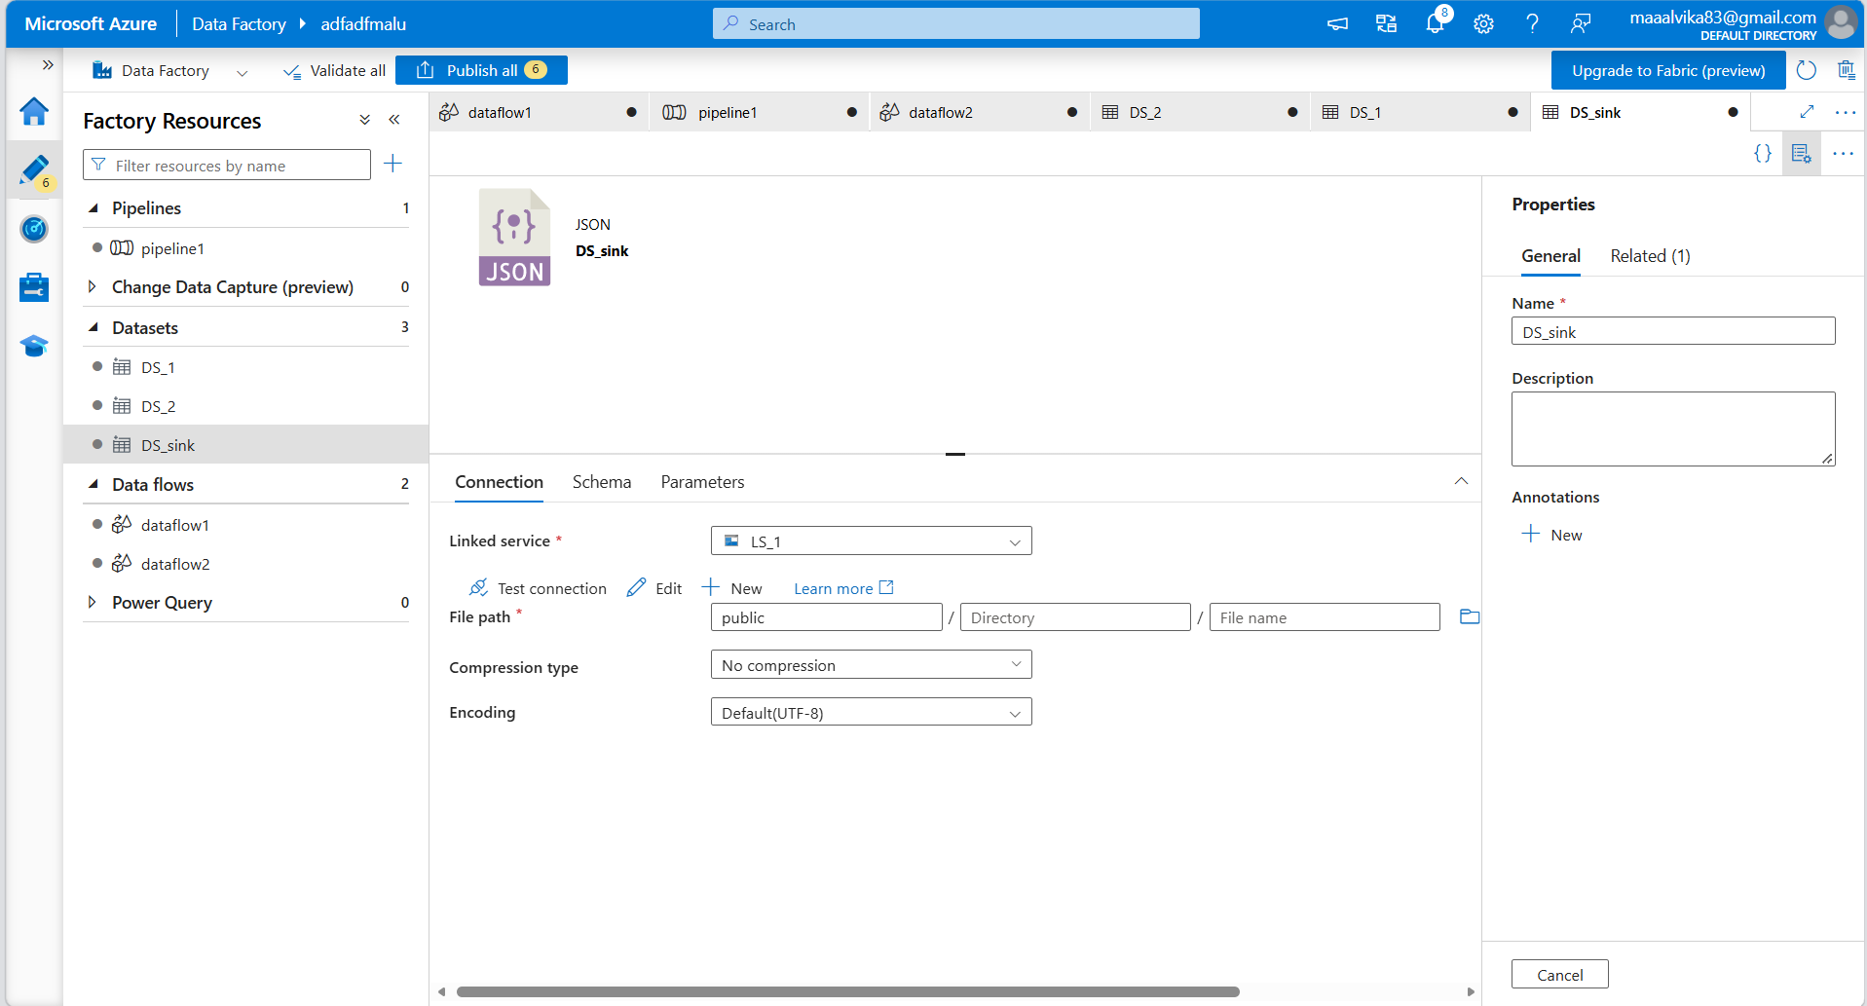
Data preview to see joined data
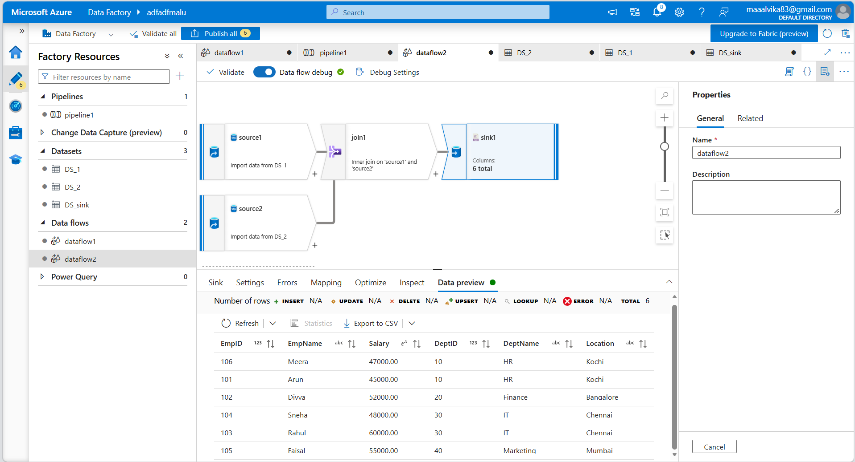

validate
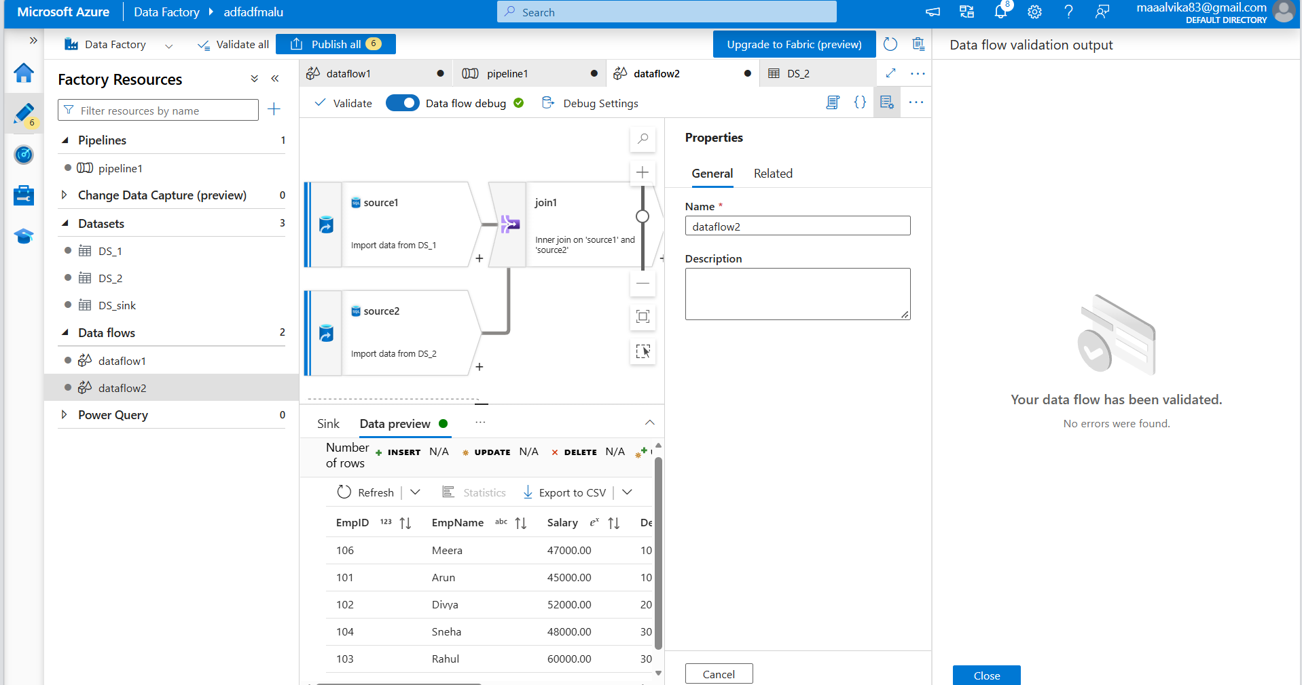
Create a new pipeline and drap&drop dataflow to it
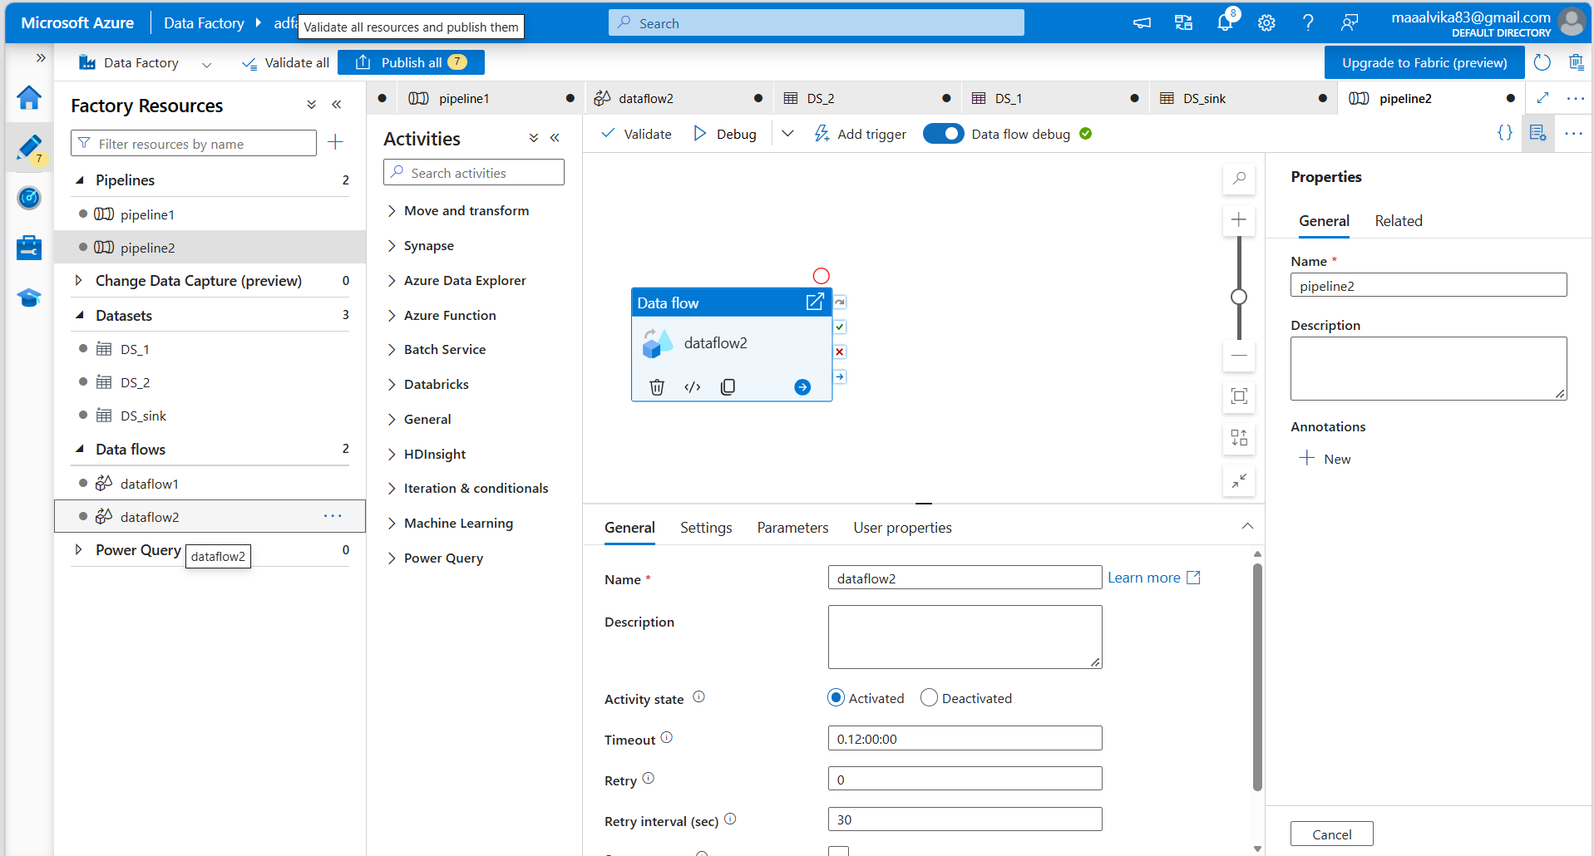

Debug
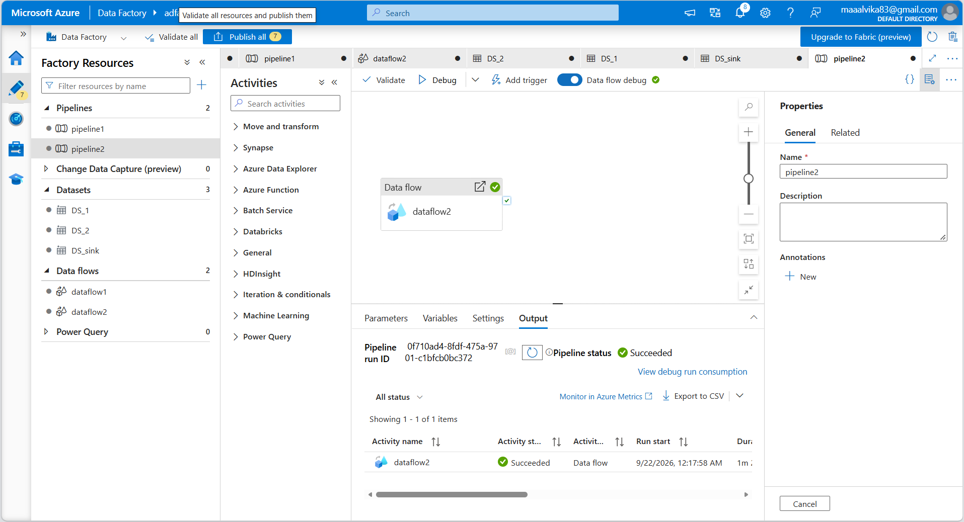
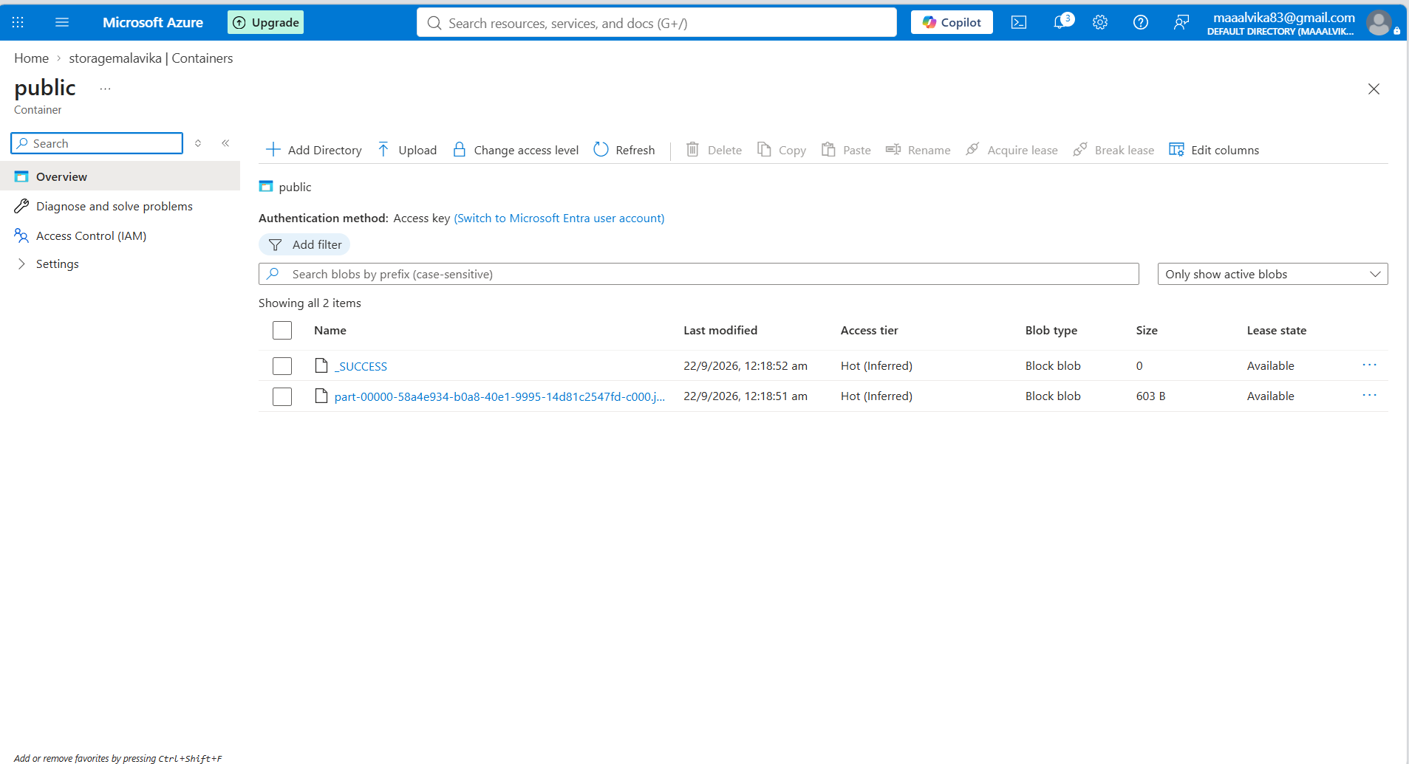

Union
Union operation is used to union the data from 2 tables employees and department placed in source1 and source2 respectively
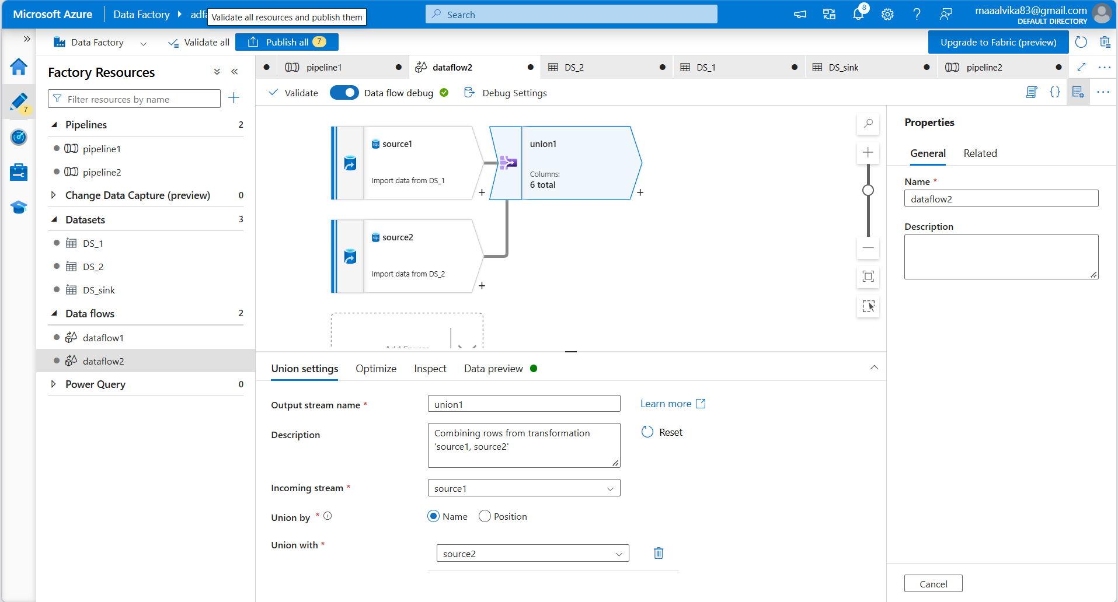
Sink is connected to union in dataflow and select the sink dataset
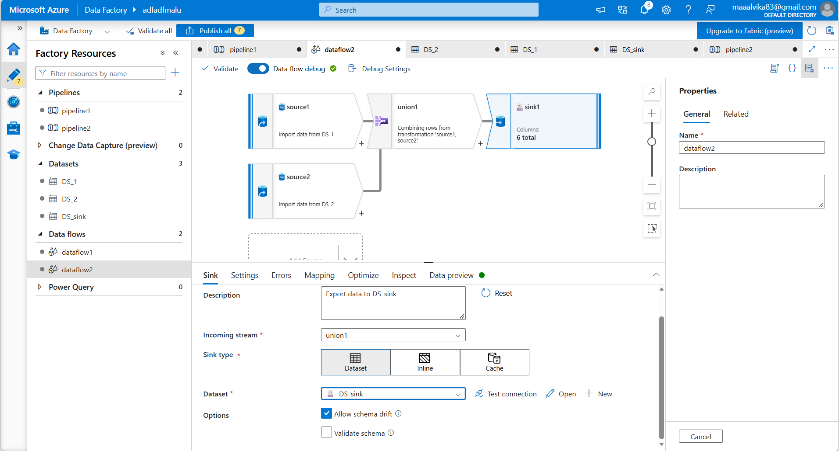

Data preview to view data
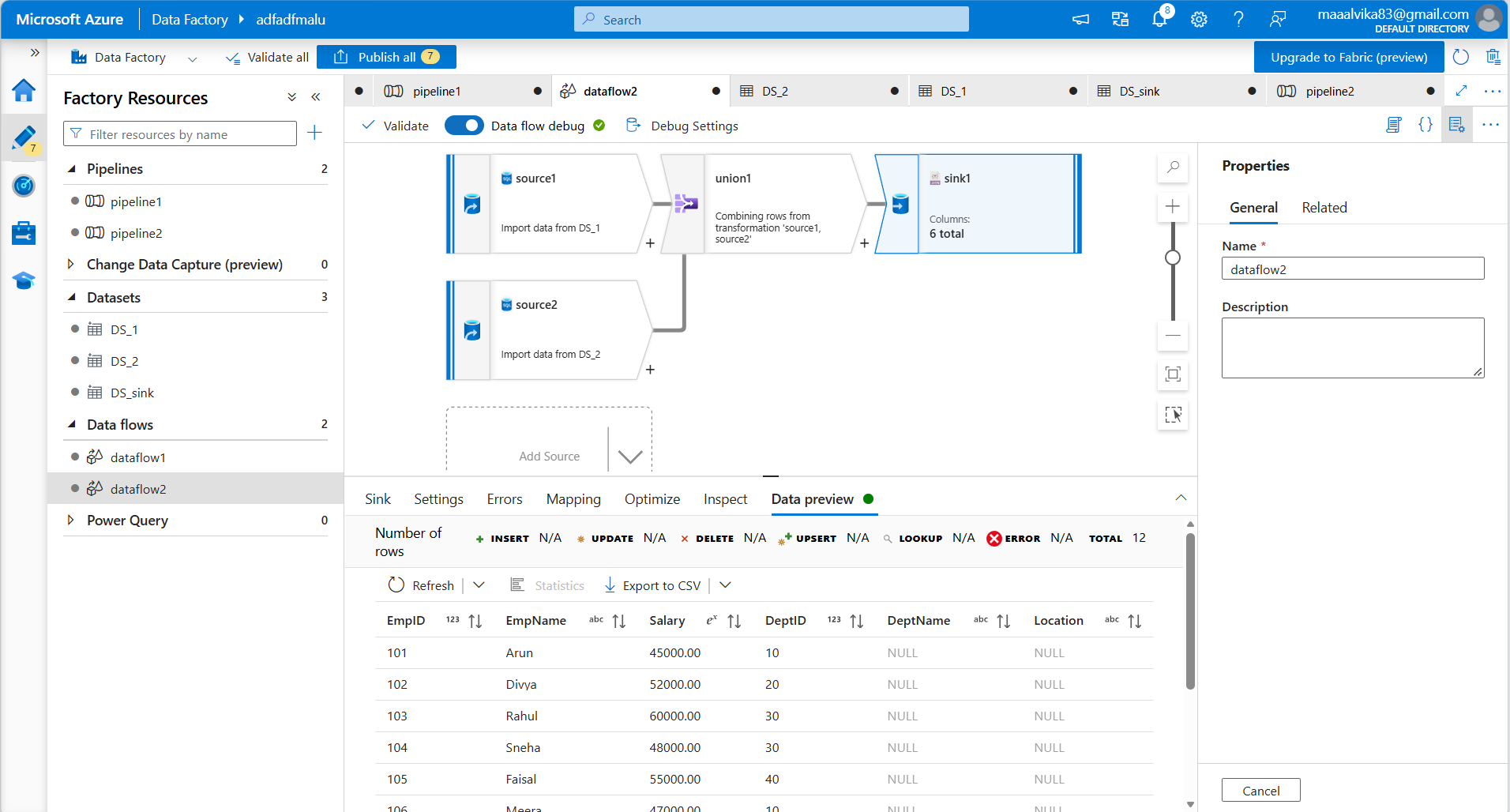
Create a new pipeline and drag&drop dataflow to it
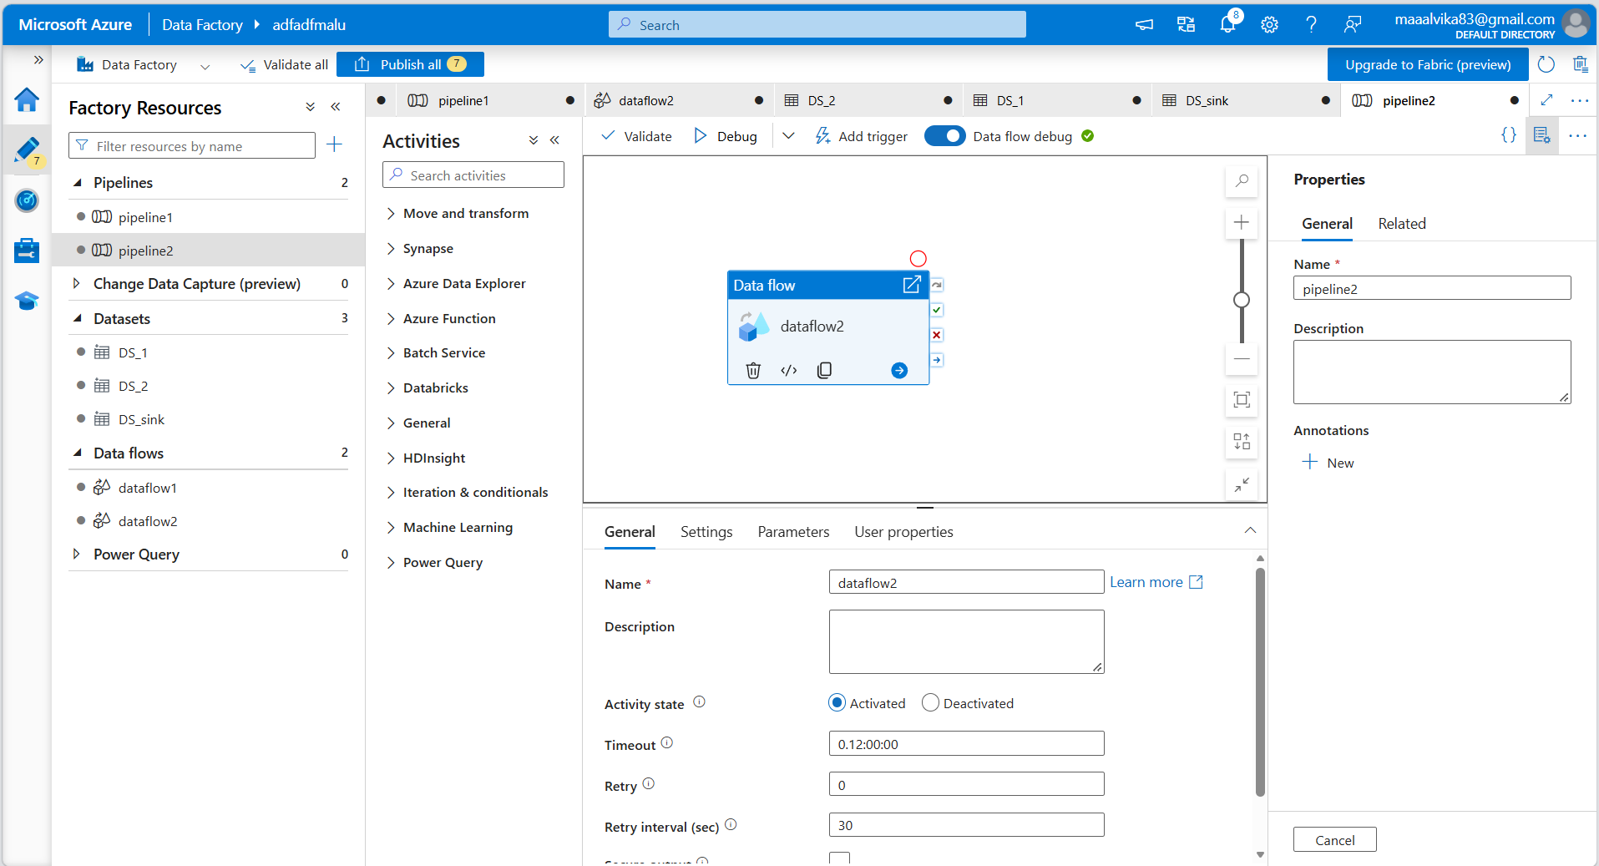

Validate and debug
